Mockito Hands-On Exercises

Exercise 1: Mocking and Stubbing
Scenario:
You need to test a service that depends on an external API. Use Mockito to mock the external API and stub its methods.

Steps:
- Create a mock object for the external API.
- Stub the methods to return predefined values.
- Write a test case that uses the mock object.

Solution Code:
import static org.mockito.Mockito.*; import org.junit.jupiter.api.Test; import org.mockito.Mockito;

public class MyServiceTest { @Test
public void testExternalApi() {
ExternalApi mockApi = Mockito.mock(ExternalApi.class); when(mockApi.getData()).thenReturn("Mock Data"); MyService service = new MyService(mockApi);
String result = service.fetchData(); assertEquals("Mock Data", result);
}
}

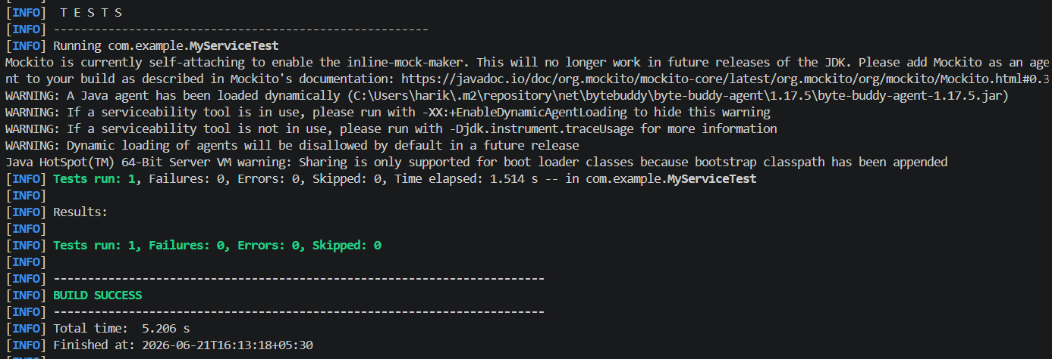

Exercise 2: Verifying Interactions
Scenario:
You need to ensure that a method is called with specific arguments.

Steps:
- Create a mock object.
- Call the method with specific arguments.
- Verify the interaction.

Solution Code:
import static org.mockito.Mockito.*;
import org.junit.jupiter.api.Test;
import org.mockito.Mockito;

public class MyServiceTest { @Test
public void testVerifyInteraction() {
ExternalApi mockApi = Mockito.mock(ExternalApi.class); MyService service = new MyService(mockApi); service.fetchData();
verify(mockApi).getData();
}
}

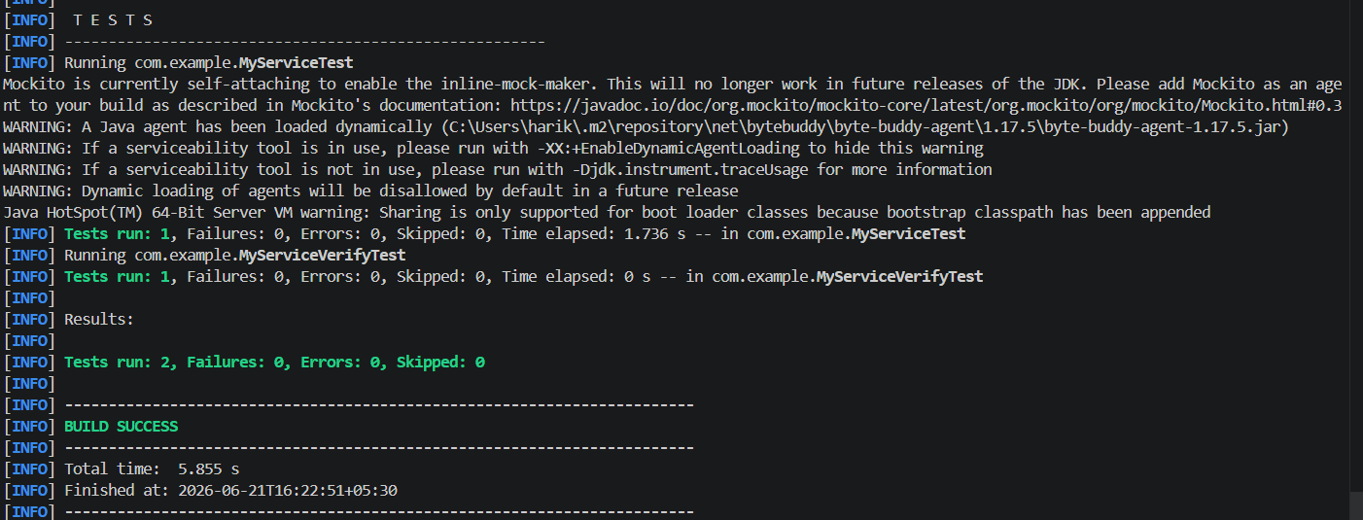

Exercise 3: Argument Matching
Scenario:
You need to verify that a method is called with specific arguments.

Steps:
- Create a mock object.
- Call the method with specific arguments.
- Use argument matchers to verify the interaction.

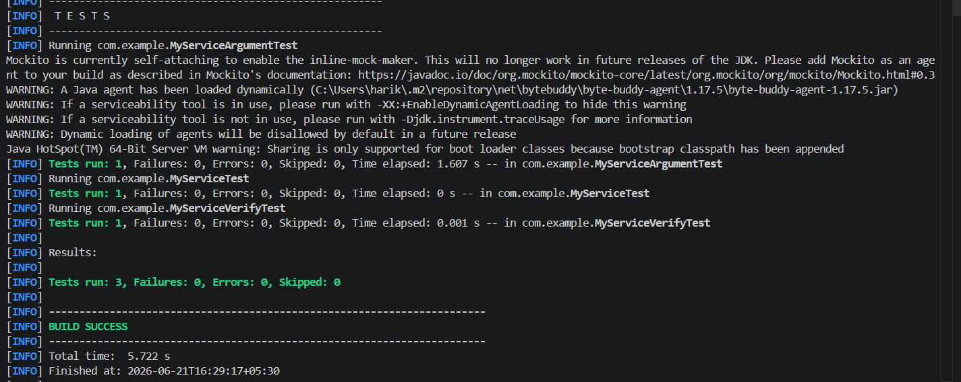

Exercise 4: Handling Void Methods
Scenario:
You need to test a void method that performs some action.

Steps:
- Create a mock object.
- Stub the void method.
- Verify the interaction.
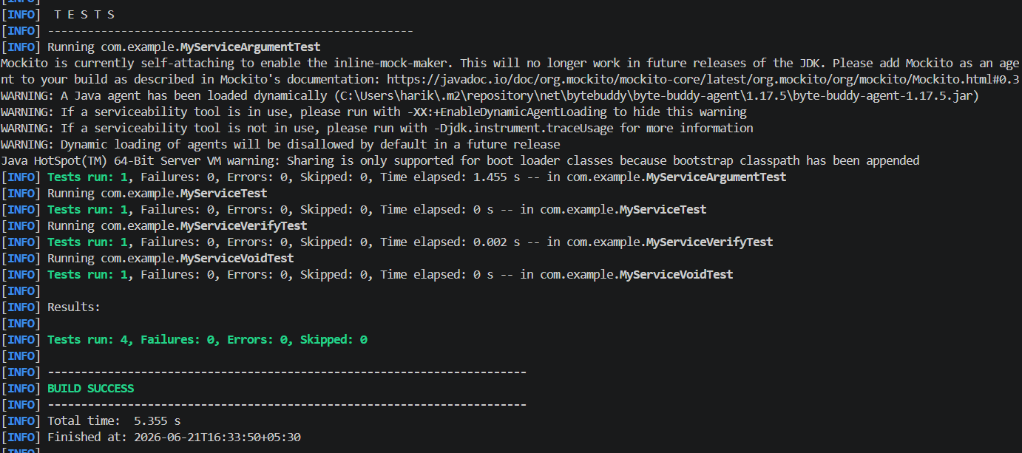

Exercise 5: Mocking and Stubbing with Multiple Returns
Scenario:
You need to test a service that depends on an external API with multiple return values.

Steps:
- Create a mock object for the external API.
2.Stub the methods to return different values on consecutive calls.
3.Write a test case that uses the mock object.

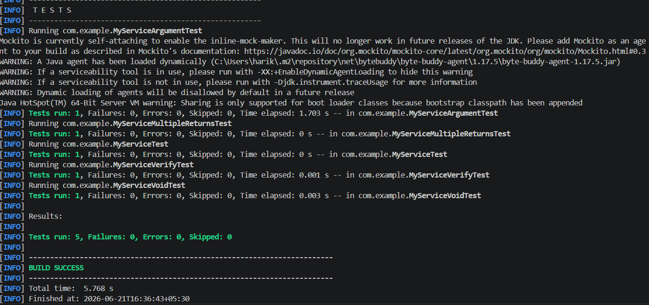

Exercise 6: Verifying Interaction Order
Scenario:
You need to ensure that methods are called in a specific order.

Steps:
- Create a mock object.
- Call the methods in a specific order.
- Verify the interaction order.

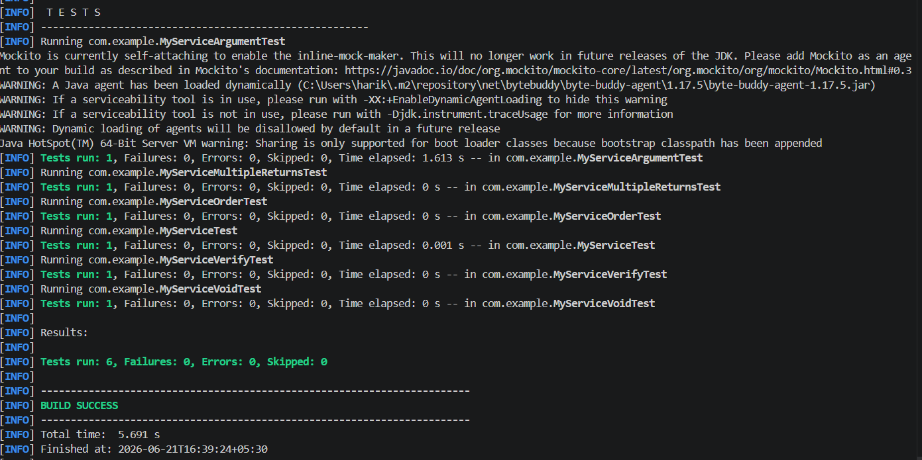

Exercise 7: Handling Void Methods with Exceptions Scenario:

You need to test a void method that throws an exception.

Steps:
- Create a mock object.
- Stub the void method to throw an exception.
- Verify the interaction. 